|  |
| --- |
|  |
| Labs of Rynth |
| Iteration 1  GitHub: <https://github.com/micle546/LabsOfRynth>  Issues and Tasks: <https://github.com/users/micle546/projects/9> |

|  |
| --- |
| Mike Eubank (meubank); Chris Coggins (ccoggins)  10-12-2022 |

## Project Status

I think we’re making good progress so far, as we are integrating the tile set we have decided to use and coming up with ideas for game mechanics and level designs. We have implemented basic player controls and are getting the feel for the scale of the level and the player objects. Next iteration, we are planning to finish out the player movement, finalizing the scale of both the player and level, and implementing basic enemy AI, and implement our first basic mechanic, potentially locked doors.

## Project tasks

Please see the following links for an up-to-date status of the current project

Project tasks categories: <https://github.com/users/micle546/projects/9/>

Iteration Overview: <https://github.com/users/micle546/projects/9/views/4/>

## Project visuals

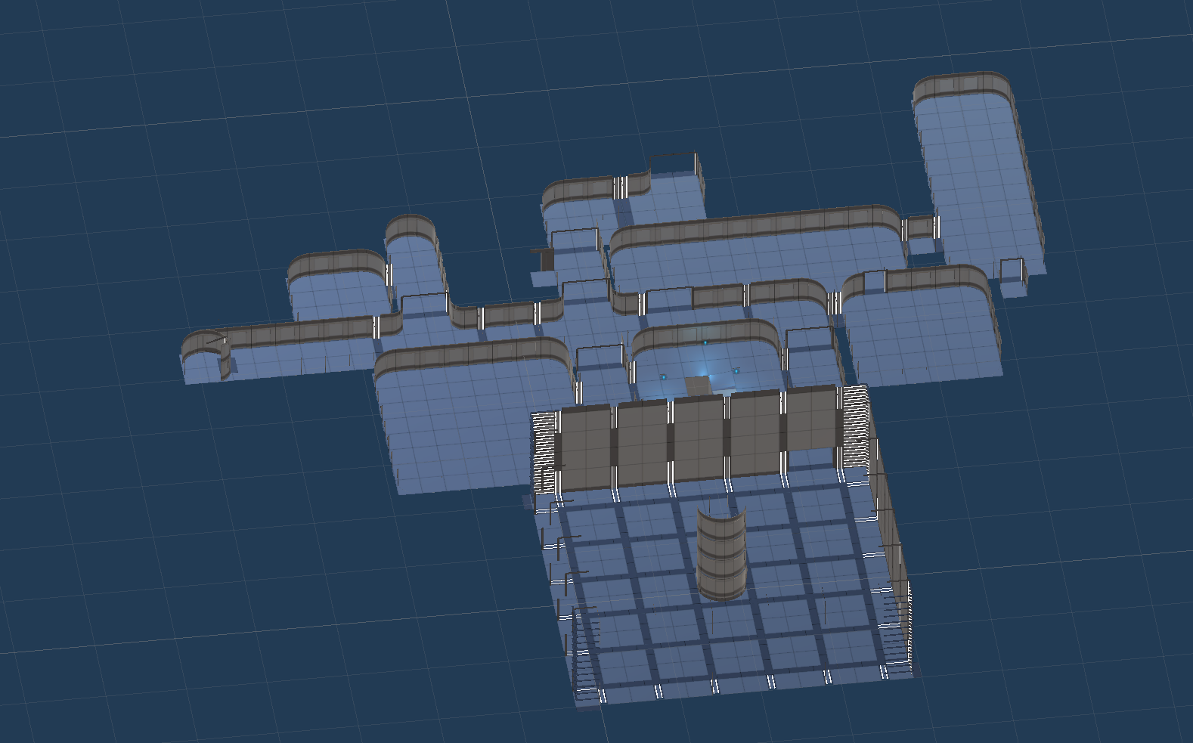

Figure - Asset Pack Imported map 1

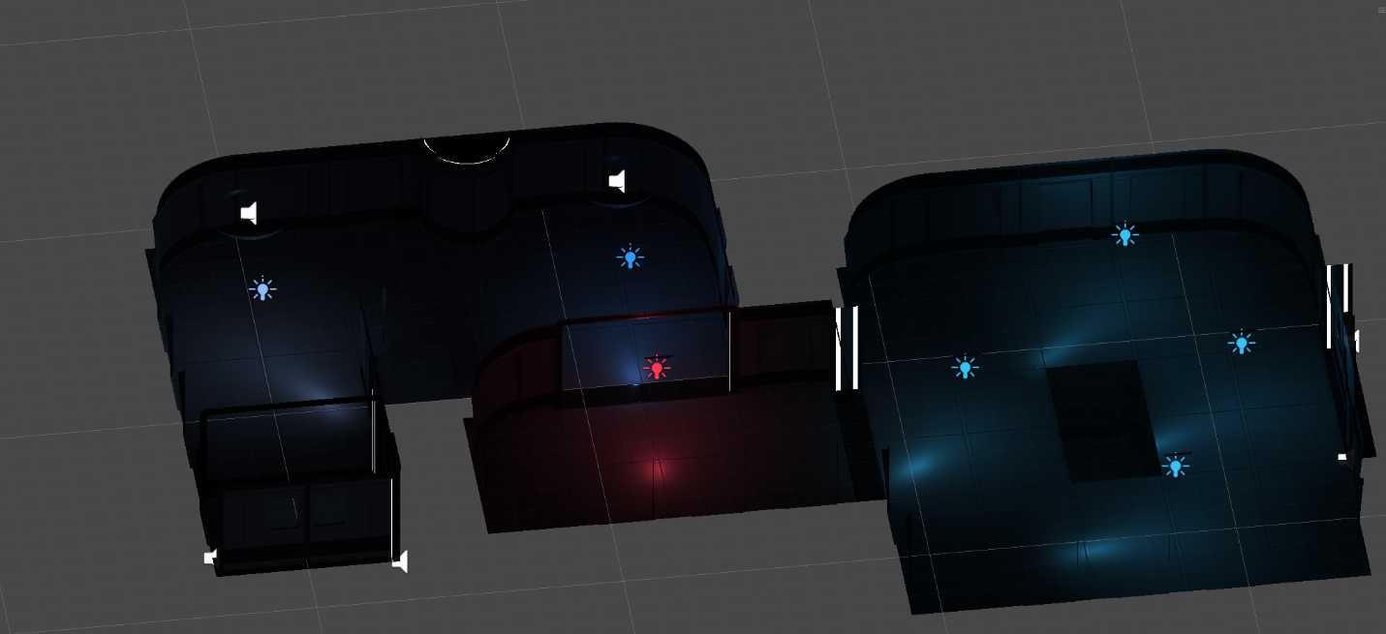

Figure - Asset Pack Imported map 2

Figure - Asset Pack Imported map 3

Figure - Maze design concept

Figure - Maze design with tiles

Figure - Maze design - additional tiles